**Introduction to TensorFlow for Artificial Intelligence, Machine Learning, and Deep Learning**

**WEEK 1**

**Repositori github**

<https://github.com/https-deeplearning-ai/tensorflow-1-public>

**Sebuah primer dalam pembelajaran mesin**

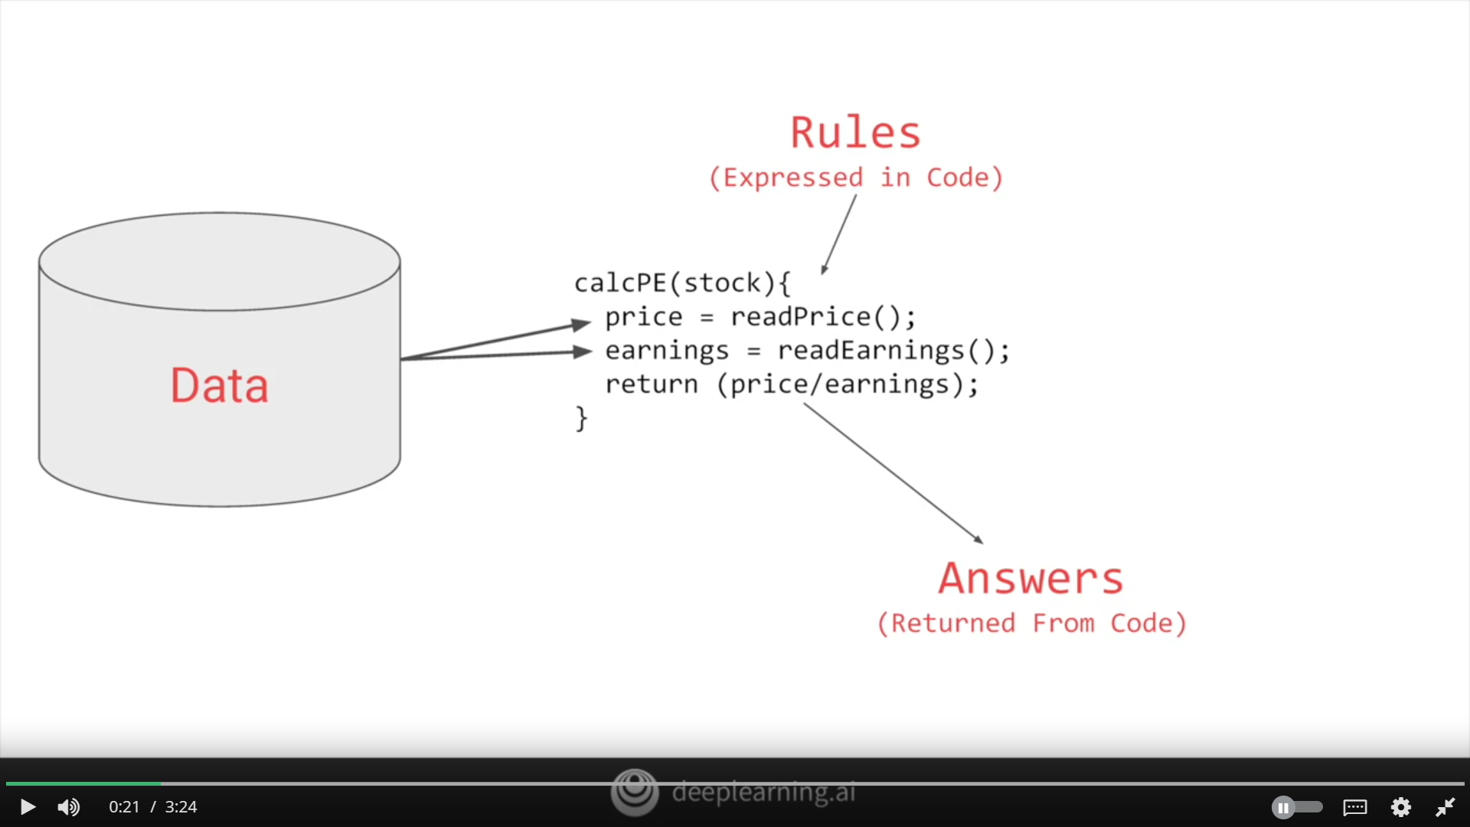

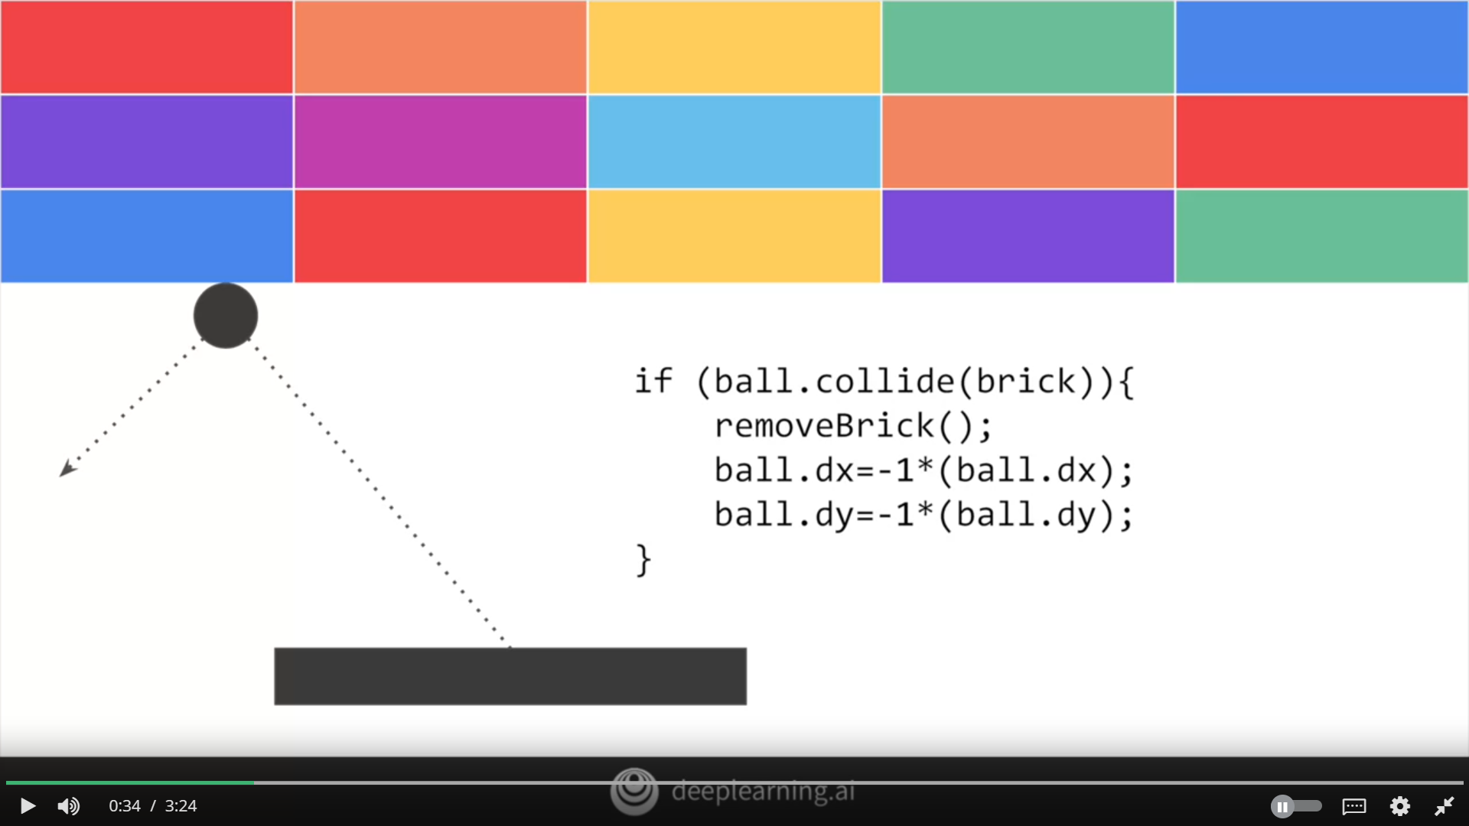

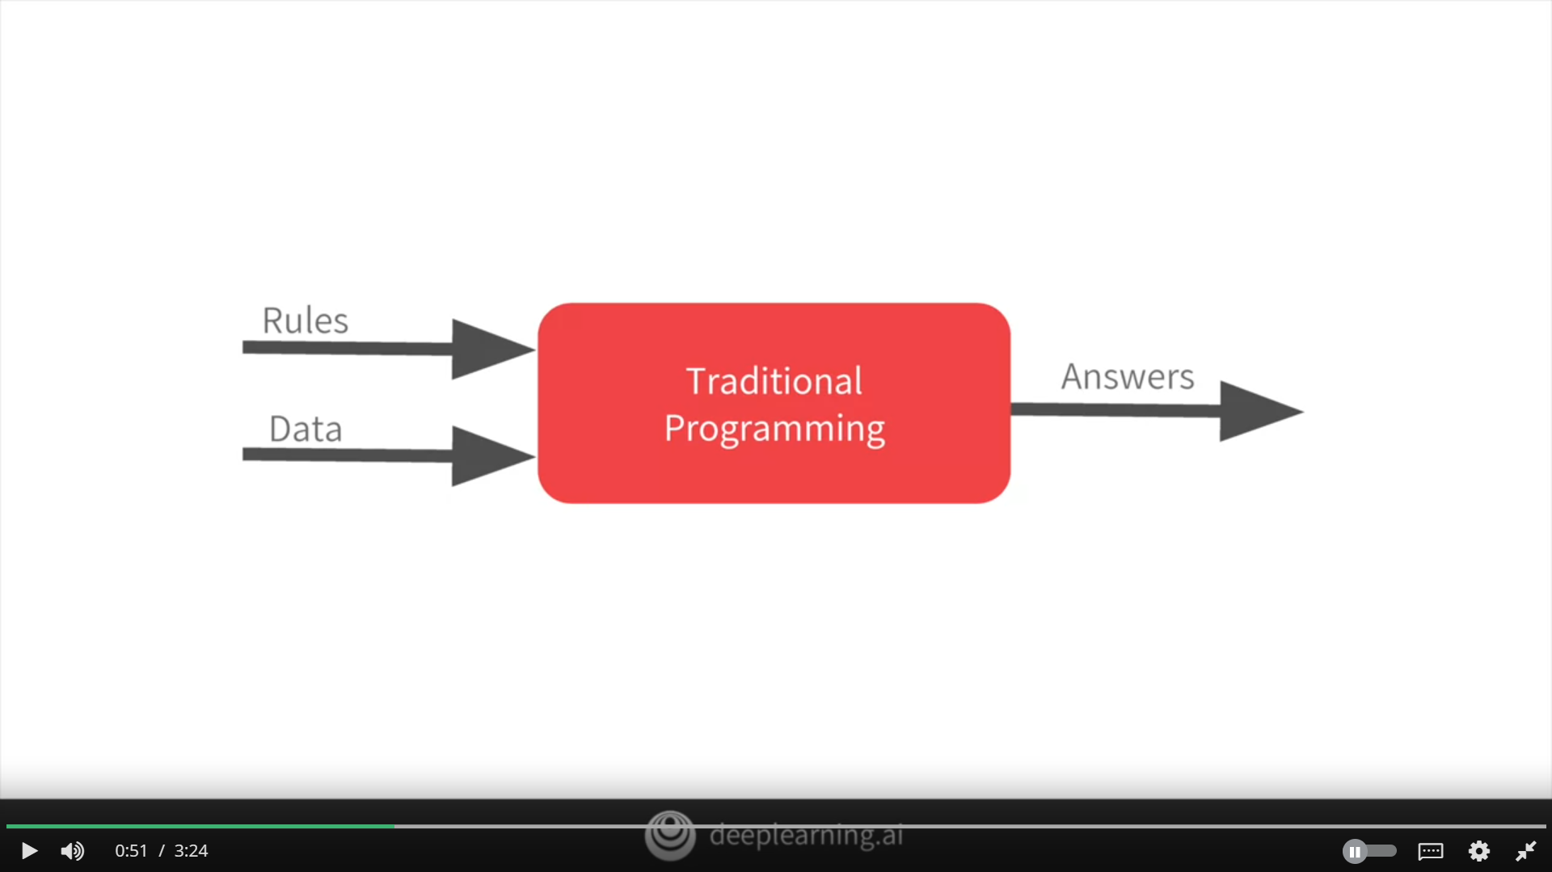

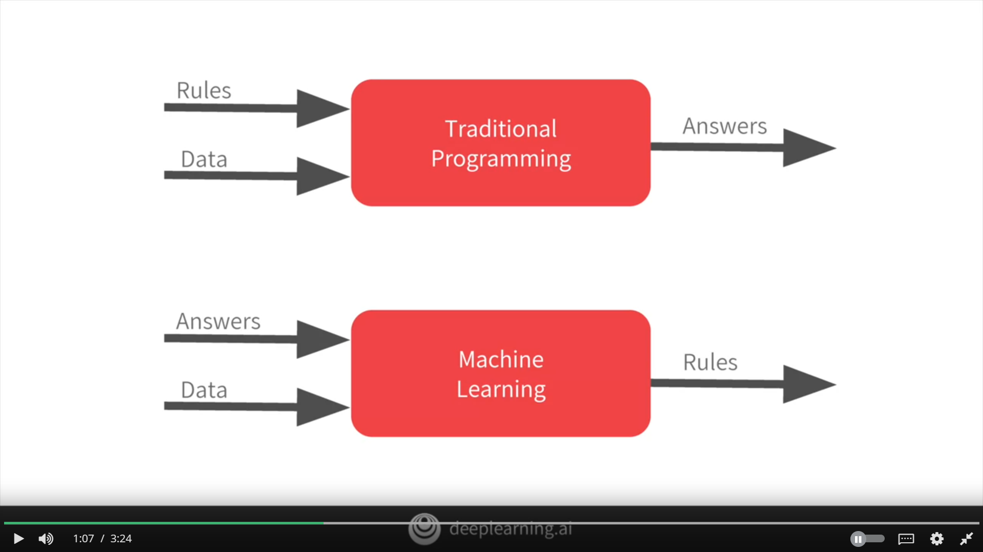

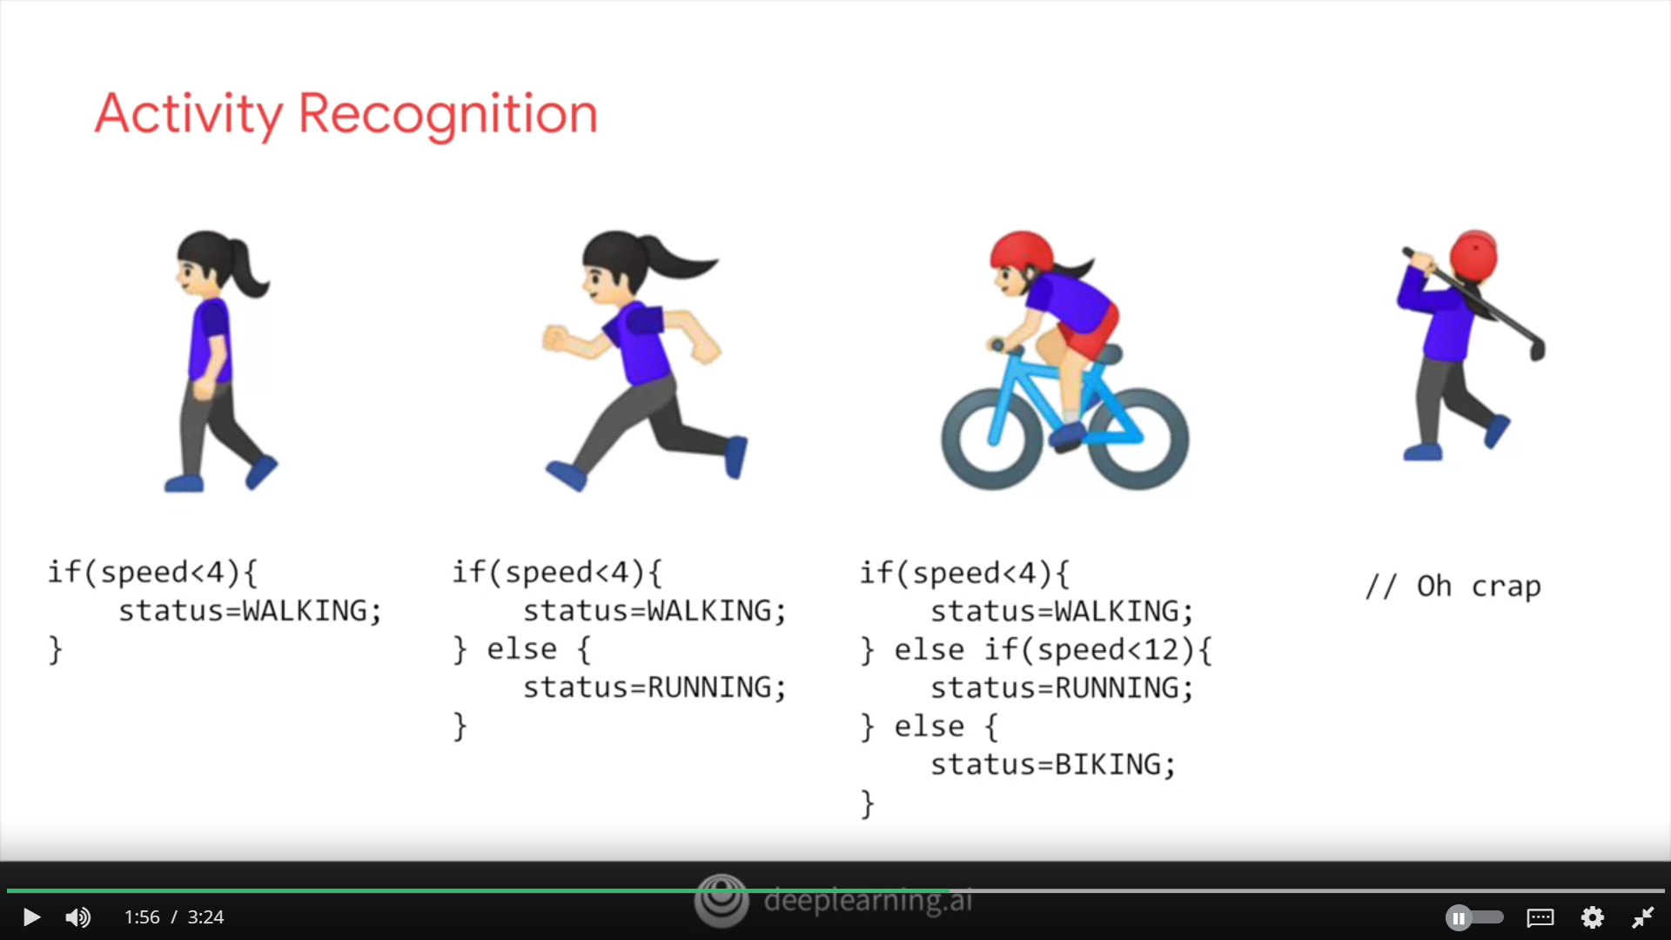

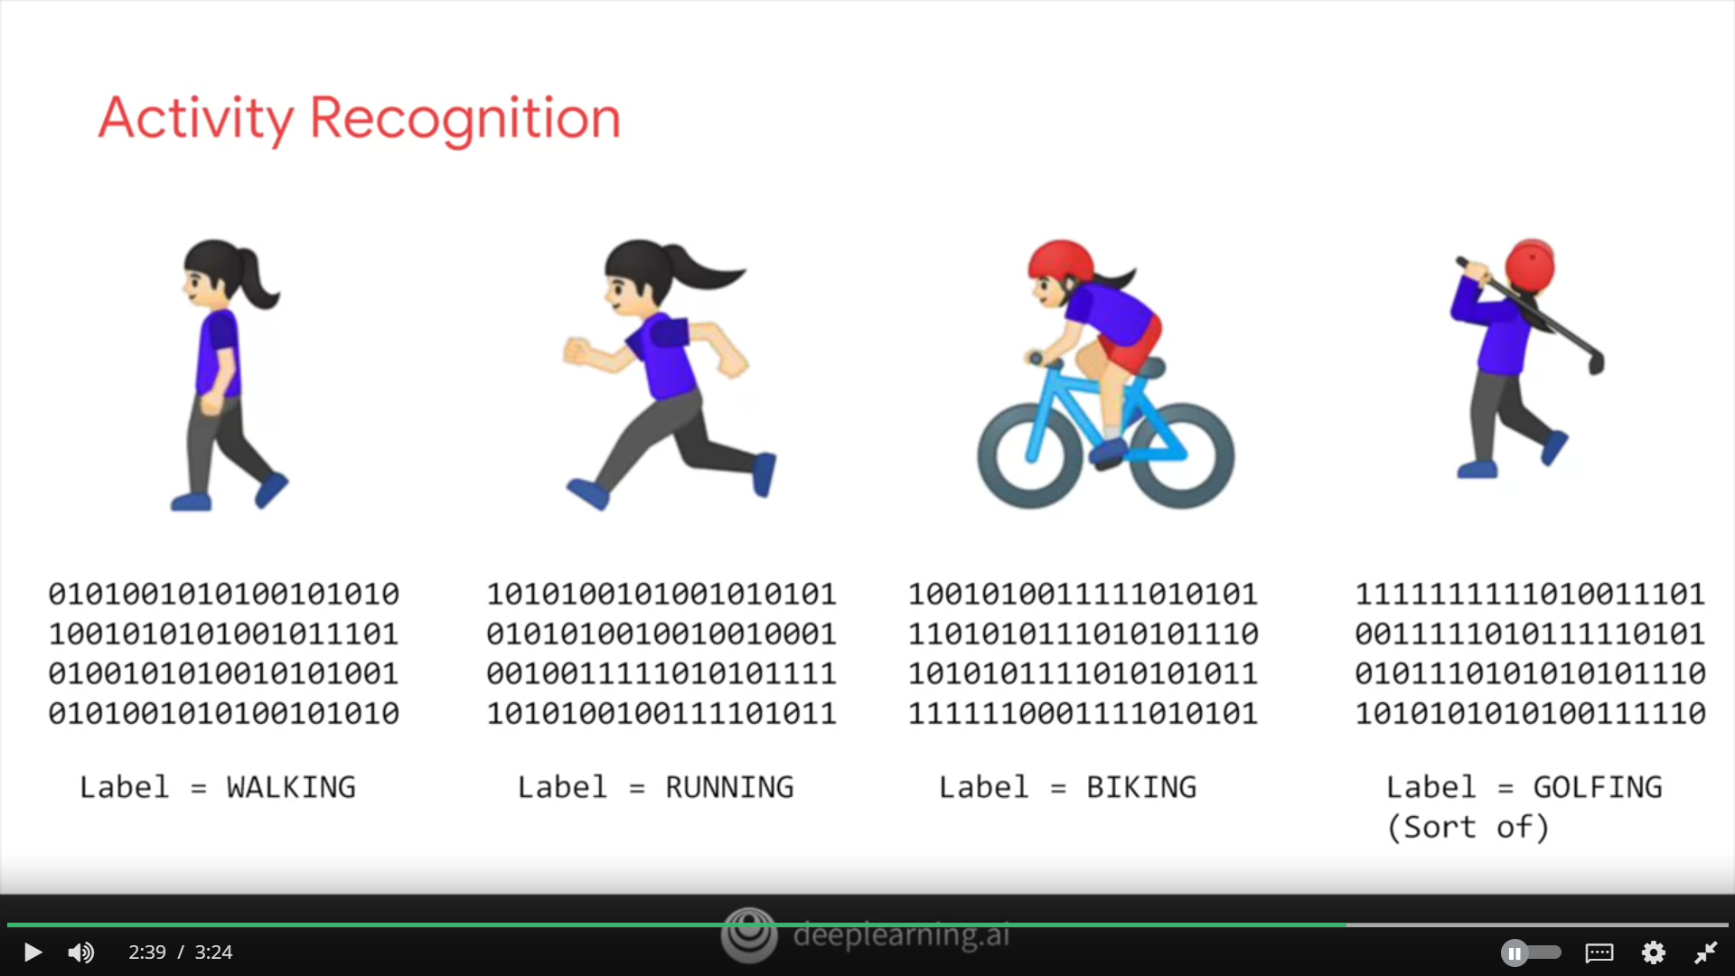

**'Hello World' dari jaringan saraf**

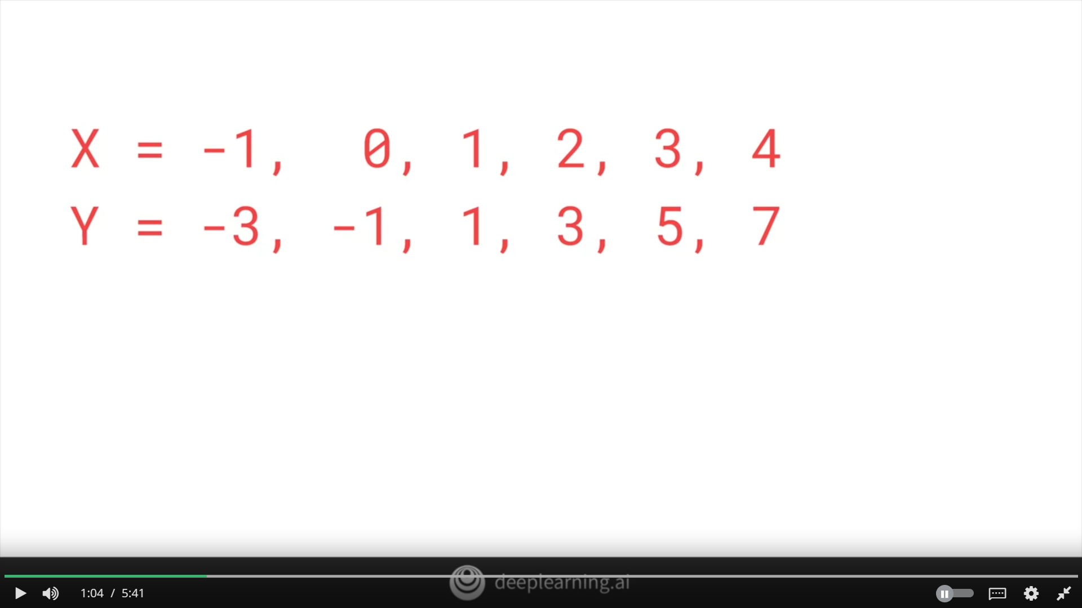

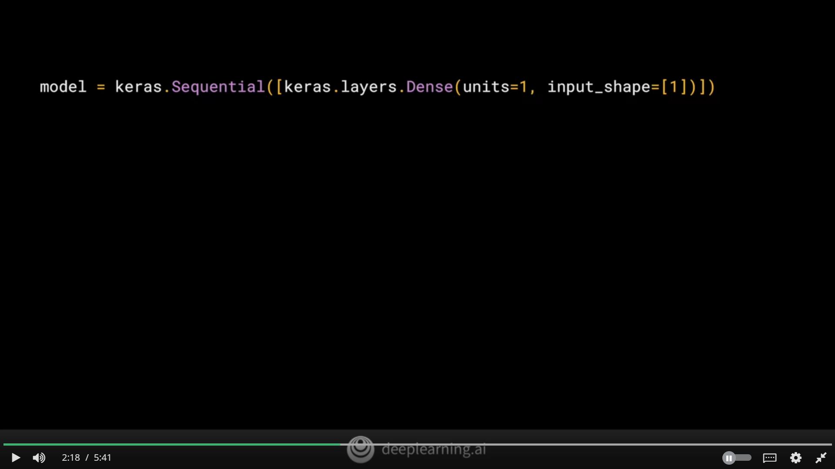

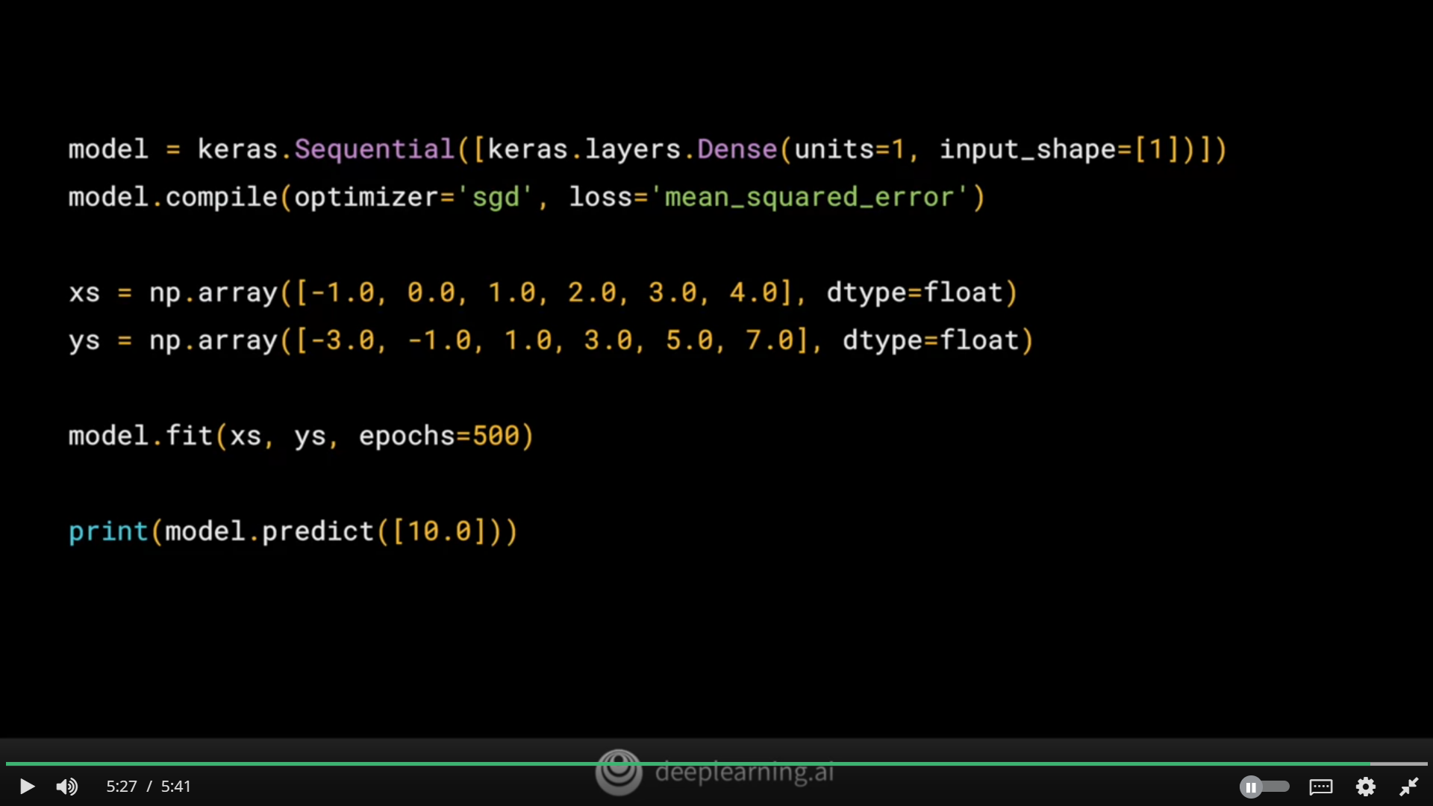

**Mengerjakan 'Hello World' di TensorFlow dan Python**